
// Q1. Write a program to input a string and find its length using strlen().
#include <iostream>
#include <cstring>
using namespace std;

int main() {
char str[100];
cout << "Enter string: ";
cin.getline(str, 100);

cout << "Length = " << strlen(str);
return 0;
}

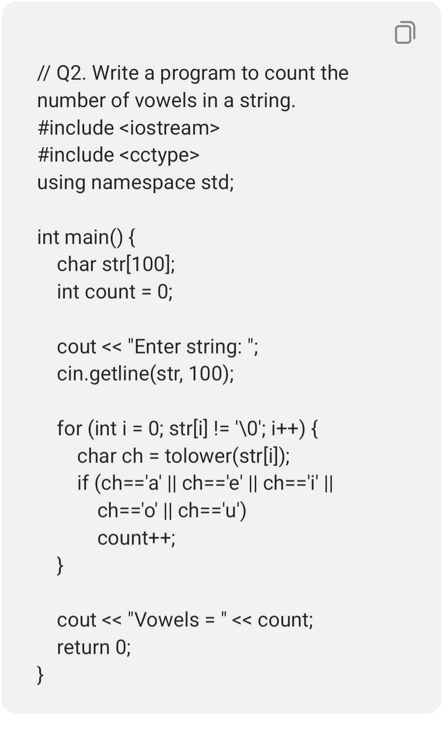

// Q3. Write a program to copy one string to another using strcpy().
#include <iostream>
#include <cstring>
using namespace std;

int main() {
char a[100], b[100];

cout << "Enter string: ";
cin.getline(a, 100);

strcpy(b, a);
cout << "Copied string = " << b;
return 0;
}

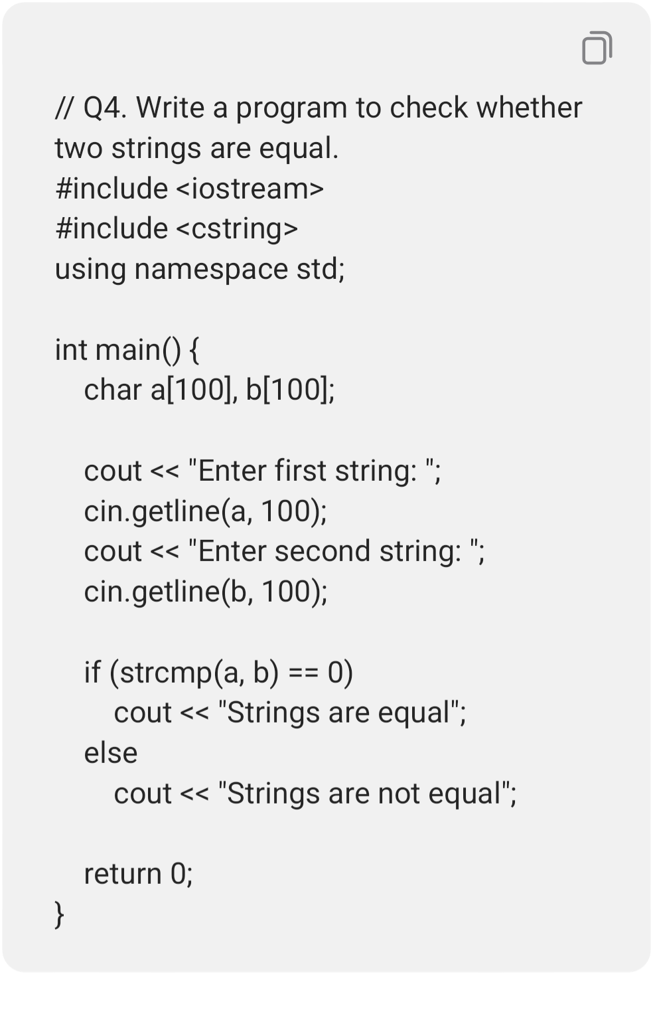

// Q5. Write a program to concatenate two strings using strcat().
#include <iostream>
#include <cstring>
using namespace std;
int main() {
char a[200], b[100];

cout << "Enter first string: ";
cin.getline(a, 200);
cout << "Enter second string: ";
cin.getline(b, 100);

strcat(a, b);
cout << "Joined string = " << a;
return 0;
}

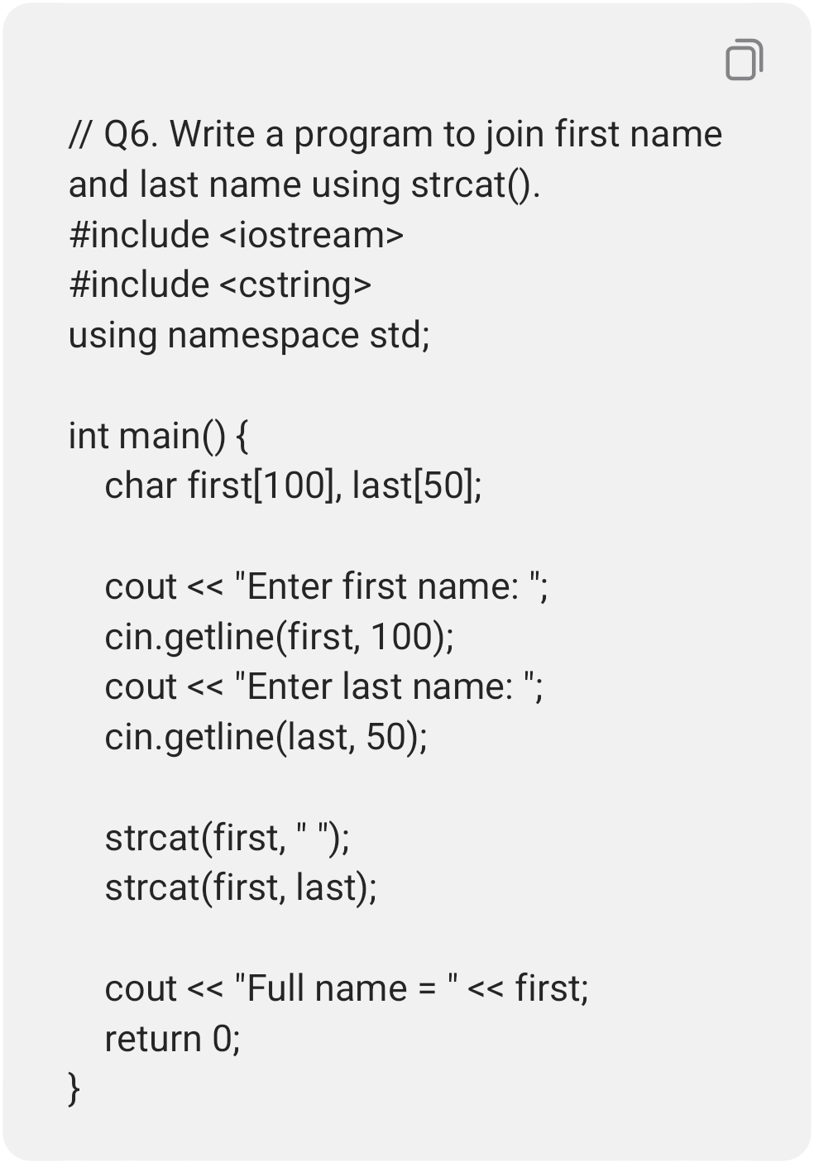

// Q7. Write a program to compare two strings using strcmp().
#include <iostream>
#include <cstring>
using namespace std;

int main() {
char a[100], b[100];

cout << "Enter first string: ";
cin.getline(a, 100);
cout << "Enter second string: ";
cin.getline(b, 100);

int result = strcmp(a, b);

if (result == 0)
cout << "Strings are equal";
else if (result < 0)
cout << "First string is smaller";
else
cout << "First string is greater";

return 0;
}

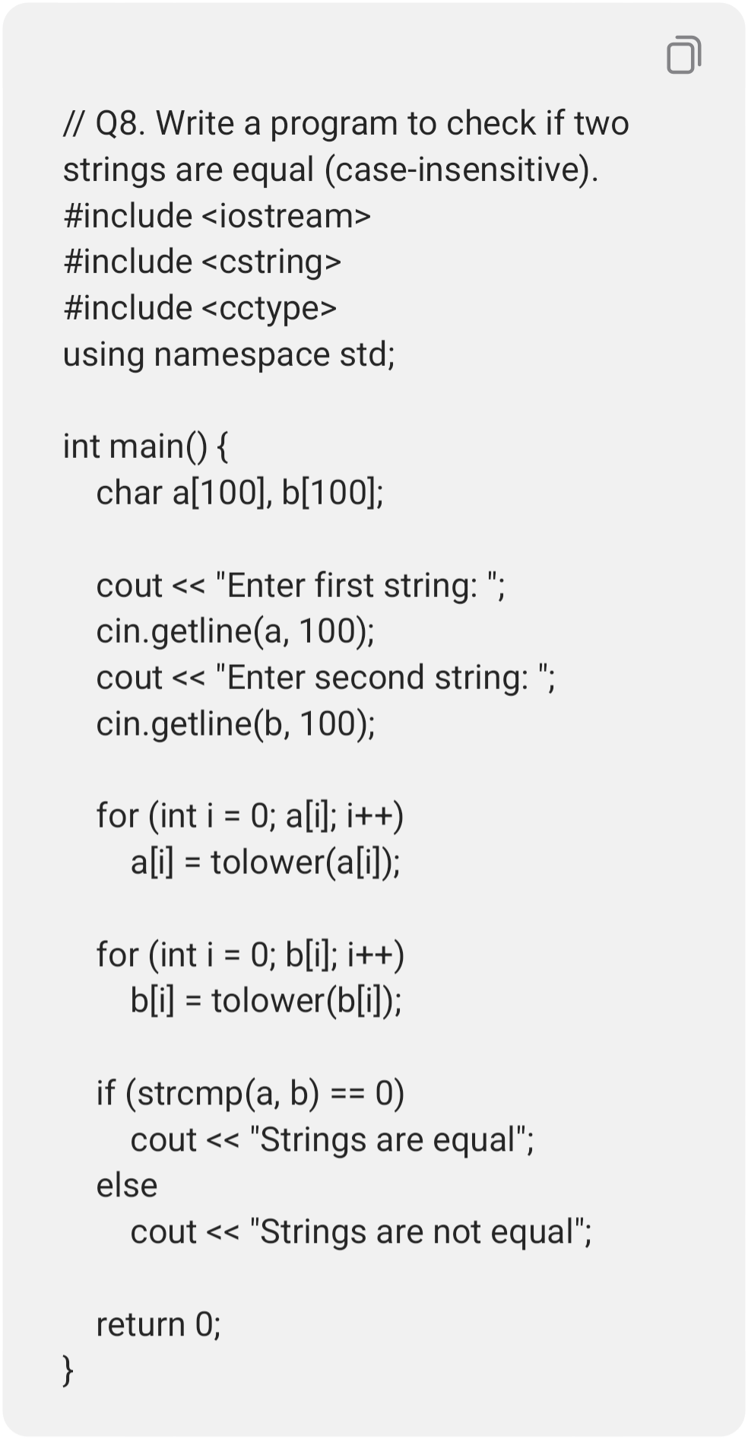

// Q9. Write a program to arrange an array of strings in alphabetical order using strcmp().
#include <iostream>
#include <cstring>
using namespace std;

int main() {
char s[5][50], temp[50];

for (int i = 0; i < 5; i++) {
cout << "Enter word: ";
cin >> s[i];
}

for (int i = 0; i < 4; i++) {
for (int j = i + 1; j < 5; j++) {
if (strcmp(s[i], s[j]) > 0) {
strcpy(temp, s[i]);
strcpy(s[i], s[j]);
strcpy(s[j], temp);
}
}
}

cout << "Alphabetical order:\n";
for (int i = 0; i < 5; i++)
cout << s[i] << endl;

return 0;
}

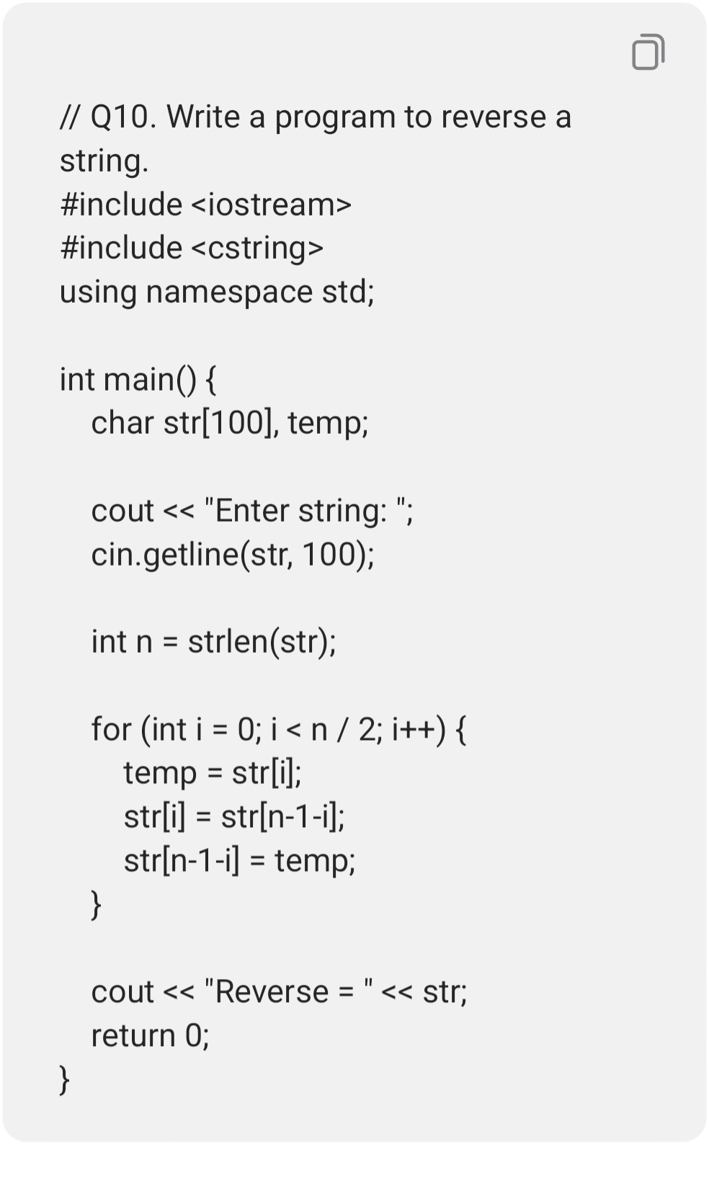

// Q11. Write a program to check if a string is palindrome.
#include <iostream>
#include <cstring>
using namespace std;

int main() {
char str[100], rev[100];

cout << "Enter word: ";
cin >> str;

strcpy(rev, str);
int n = strlen(rev);

for (int i = 0; i < n / 2; i++) {
char temp = rev[i];
rev[i] = rev[n-1-i];
rev[n-1-i] = temp;
}

if (strcmp(str, rev) == 0)
cout << "Palindrome";
else
cout << "Not palindrome";

return 0;
}
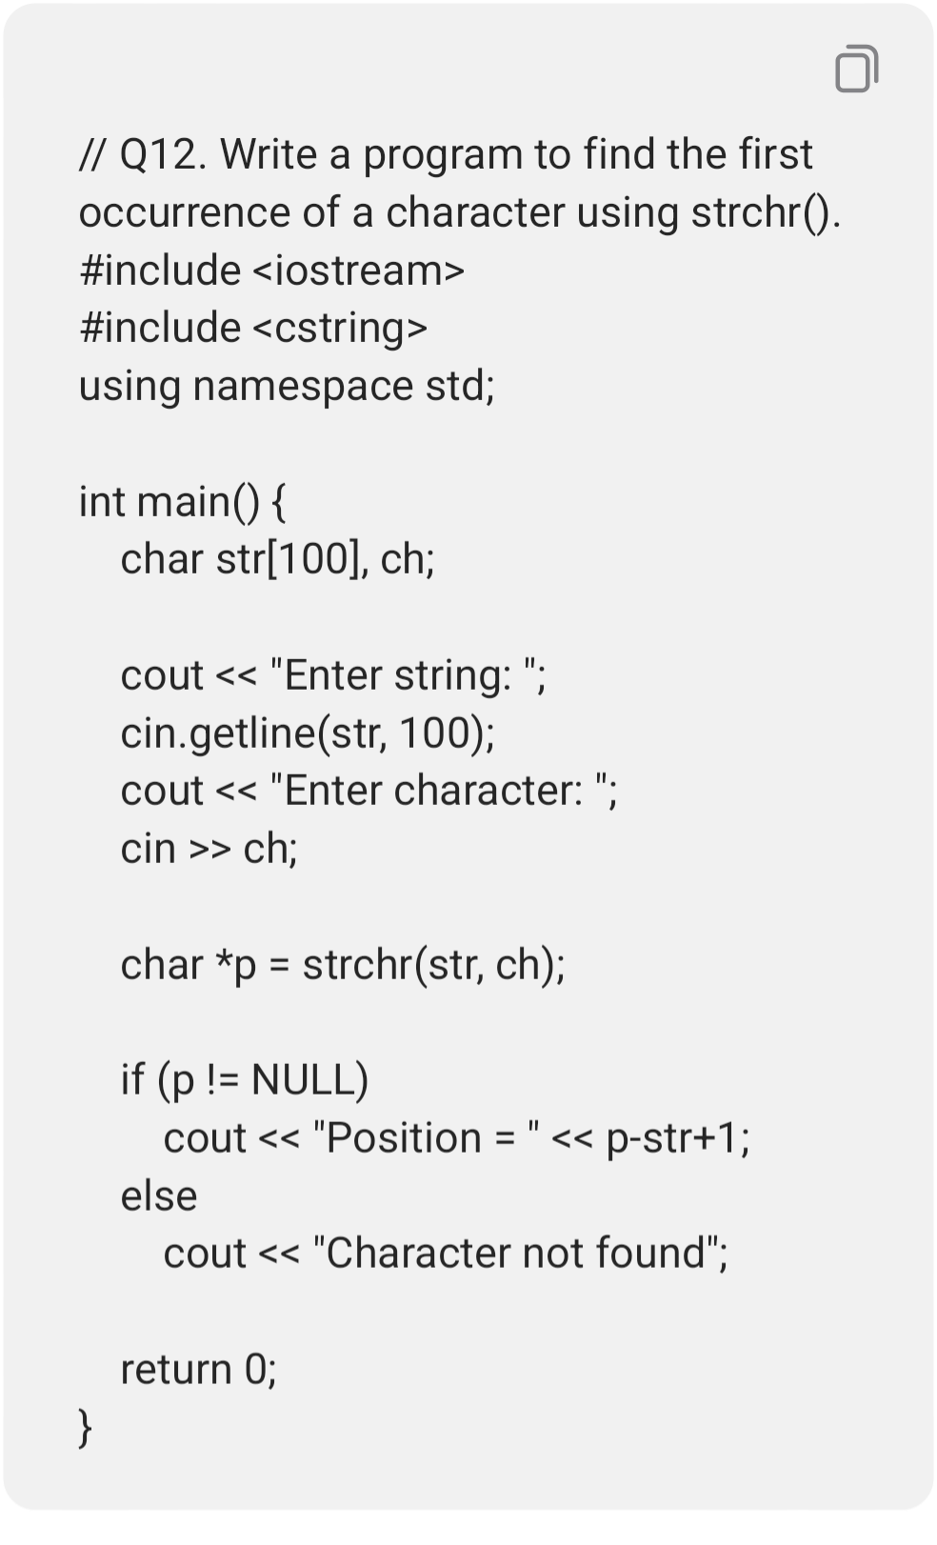

// Q13. Write a program to find the last occurrence of a character using strrchr().
#include <iostream>
#include <cstring>
using namespace std;

int main() {
char str[100], ch;

cout << "Enter string: ";
cin.getline(str, 100);
cout << "Enter character: ";
cin >> ch;

char *p = strrchr(str, ch);

if (p != NULL)
cout << "Last position = " << p-str+1;
else
cout << "Character not found";

return 0;
}
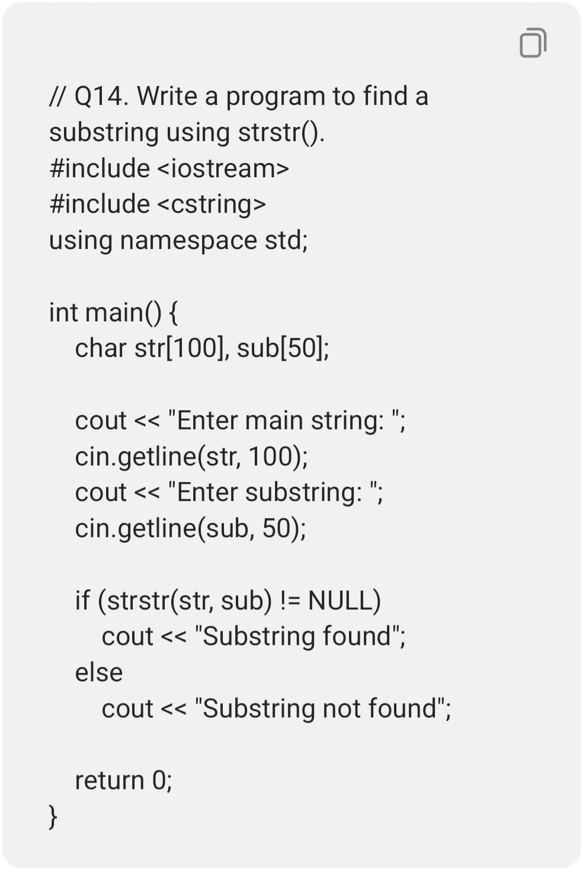

// Q15. Write a program to check if one string is present in another using strstr().
#include <iostream>
#include <cstring>
using namespace std;

int main() {
char a[100], b[50];
cout << "Enter main string: ";
cin.getline(a, 100);
cout << "Enter search string: ";
cin.getline(b, 50);

if (strstr(a, b) != NULL)
cout << "String is present";
else
cout << "String is not present";

return 0;
}

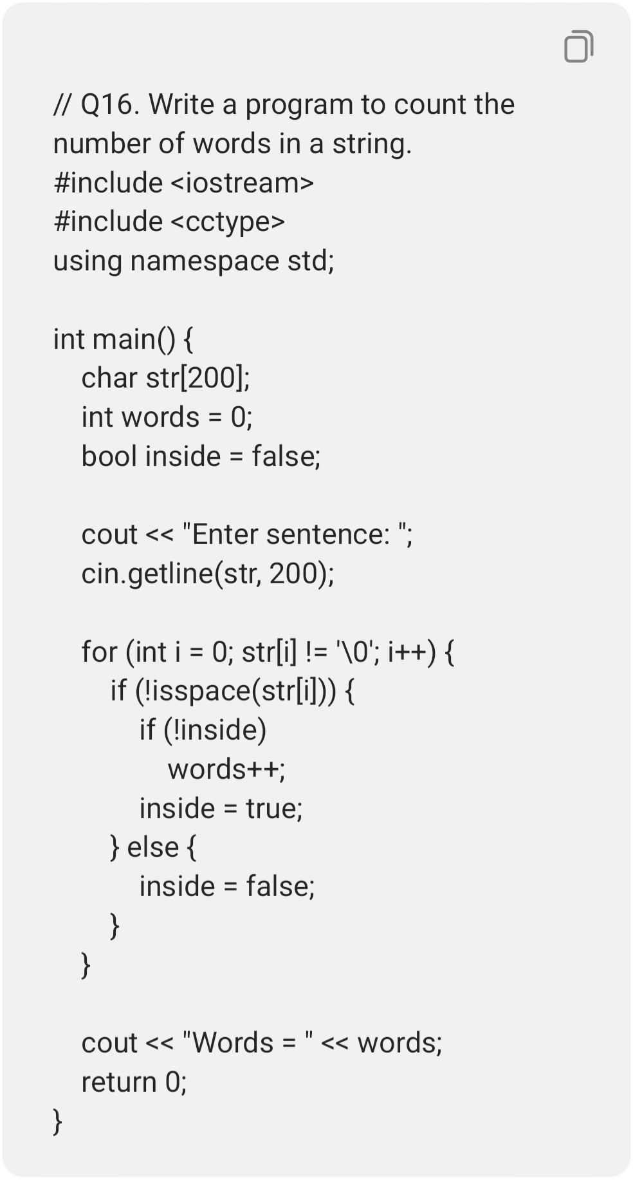

// Q17. Write a program to remove all vowels from a string.
#include <iostream>
#include <cctype>
using namespace std;

int main() {
char str[100];
int j = 0;

cout << "Enter string: ";
cin.getline(str, 100);

for (int i = 0; str[i] != '\0'; i++) {
char ch = tolower(str[i]);

if (ch!='a' && ch!='e' && ch!='i' &&
ch!='o' && ch!='u') {
str[j++] = str[i];
}
}
str[j] = '\0';
cout << "String without vowels = " << str;
return 0;
}
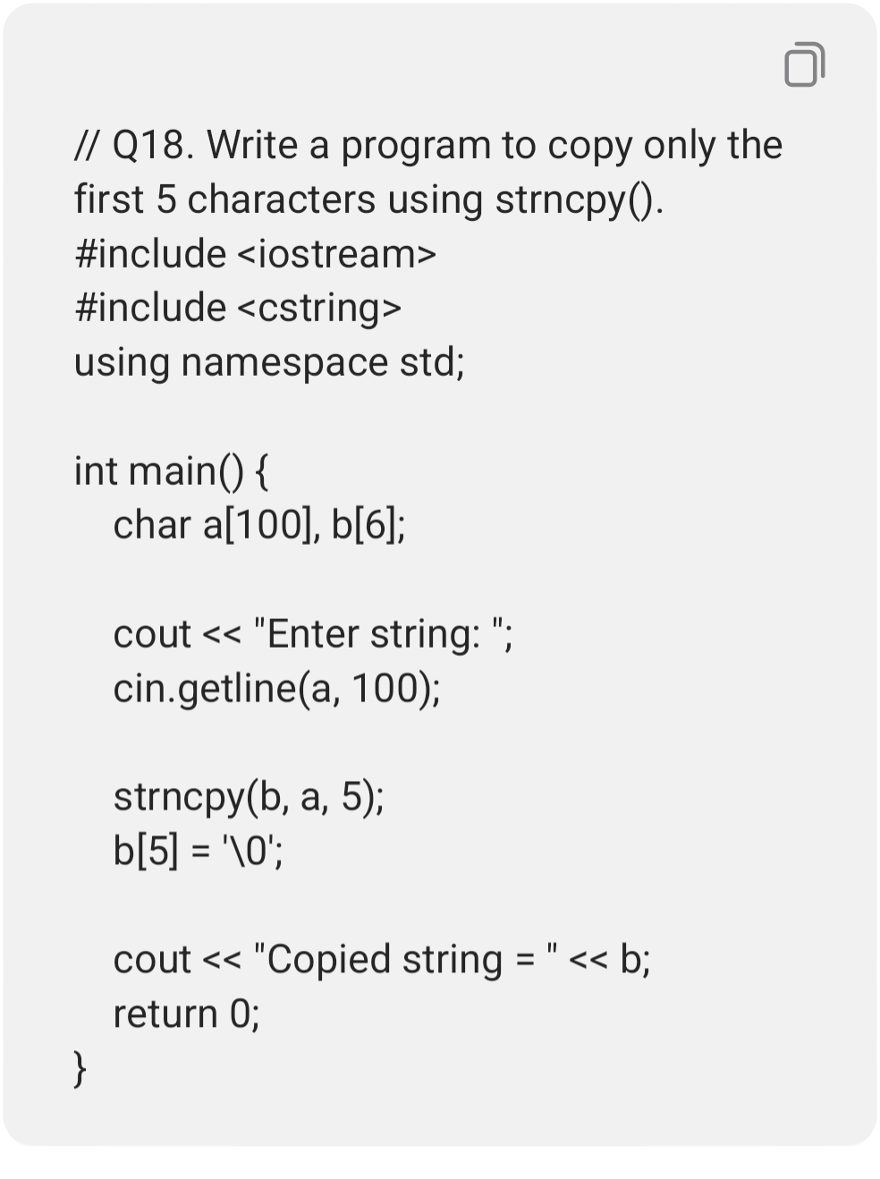

// Q19. Write a program to join multiple strings into one sentence using strcat().
#include <iostream>
#include <cstring>
using namespace std;

int main() {
char sentence[300] = "";
char word[100];

for (int i = 0; i < 3; i++) {
cout << "Enter word: ";
cin >> word;

if (i > 0)
strcat(sentence, " ");
strcat(sentence, word);
}

cout << "Sentence = " << sentence;
return 0;
}

